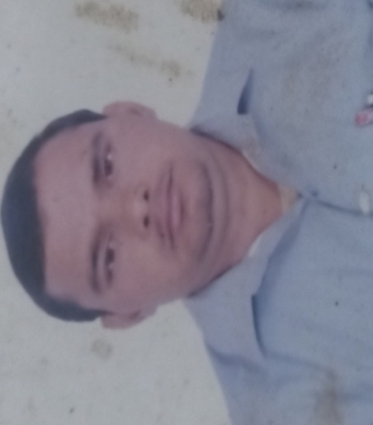
JASRAM SINGH
MARKETER & BRAND
STRATEGIST

Email id-jasramgll@gmail.com
Mo-8218568766
- OBJECTIVE- Take advantage of sales skills & experience and understanding of markete to become a professional sales staff and bring a lot value to customers .From that,I will contribute to development of my company
- WORK EXPERIENCE OF SALES
- SHRI JI KHAAD BEEJ BHANDAR(MATHURA)-2021 TO CURRENT
- Brand Building & Creating Strategies
- Sales ‘’AGGRICULTURAL PHARMA’’ Product
- Launch new product in the Market
- Brand establishment in the Market
- Strong relationship with customer & Retailer
- Double sales in the Market with in two year
- Marketing & Advertisement of many product in rural area as well as urban area
- M.SC(Chemistry) -2019 TO 2020
- RANBAXY PHARMACEUTICALS(MATHURA)-2013 TO 2O18
- Company Launch a new Pharma Division with a name of ‘’Pharma Life”
- I work there as a sales executive
- Make strong relationship with customer
- New Product Development
- Convert customer from other company Brand to our company Brand
- Covered urban area with rural area

- LUPIN PHARMACEUTICALS(LUCKNOW)-2010 TO 2012
- Work as a Sales Execuiteves
- (King George Medical College Lucknow & ERA Medical College Lucknow)
- Sales PHARMACEUTICALS PRODUCT
- Launch new product in the Market
- Brand establishment
- Strong relationship with customer
- High growth in sales with
- Regular feedback from customer

- EDUCATION:
- -M.B.A (Marketing &International Business) –
      - 2008 TO 2010
      - (From Bharat Institute of Technology Meerut)
      - Complete a project on:Strategies to be adopted by PARAG to
      - counter AMUL milk sales in MEERUT”
- B.SC(ZBC) 2006 TO 2008 (From Agra university)
- T.B.H.V- 2005 From New Delhi(Tuberculosis Health Visitor Course)
- 12th - 2004 From Allahabad university with 1st DIVISION
- 10th- 2002 From Allahabad university with 2nd DIVISION
LANGUAGE : HINDI&ENGLISH
COMPUTER: Basic knowledge of computer
(Excel,PPT,Word)

HOBBY: Reading books & listening to music

PERSONAL DETAILS

      - Date of Birth:1st May 1987

      - Ballabhgarh,Faridabad (HARYANA) Mo-8218568766

